***18.1.0***

**Payment Cartridge**

**Test Cases**

***int_sezzle***

**Table of Contents**

1. Introduction 2

2. Place an Order 3

3. Check the Order 7

4. Refund 8

# Introduction

Sezzle has a sandbox that can be used for testing. In Business Manager, navigate to the SiteGenesis Site -> Site Preferences->Custom Preferences. A custom site preference group with the ID SEZZLE_PAYMENT is available. Please select it and locate ‘Sezzle Mode’. Select ‘Sandbox’ as the mode for testing and add the credentials for sandbox account – ‘API Public Key’ and ‘API Private Key’

Once the cartridge installed and configured as described in the documentation, you can proceed with a test transaction.

In order to make sure the installation is working as expected, 3 simple steps are required: place an order, check the order, check the transaction.

# Place an order

**Step 1**

Add products into the cart and proceed with the checkout process. Once on the billing page, select the payment option named Sezzle and click on the ‘Continue to Place Order’ button.

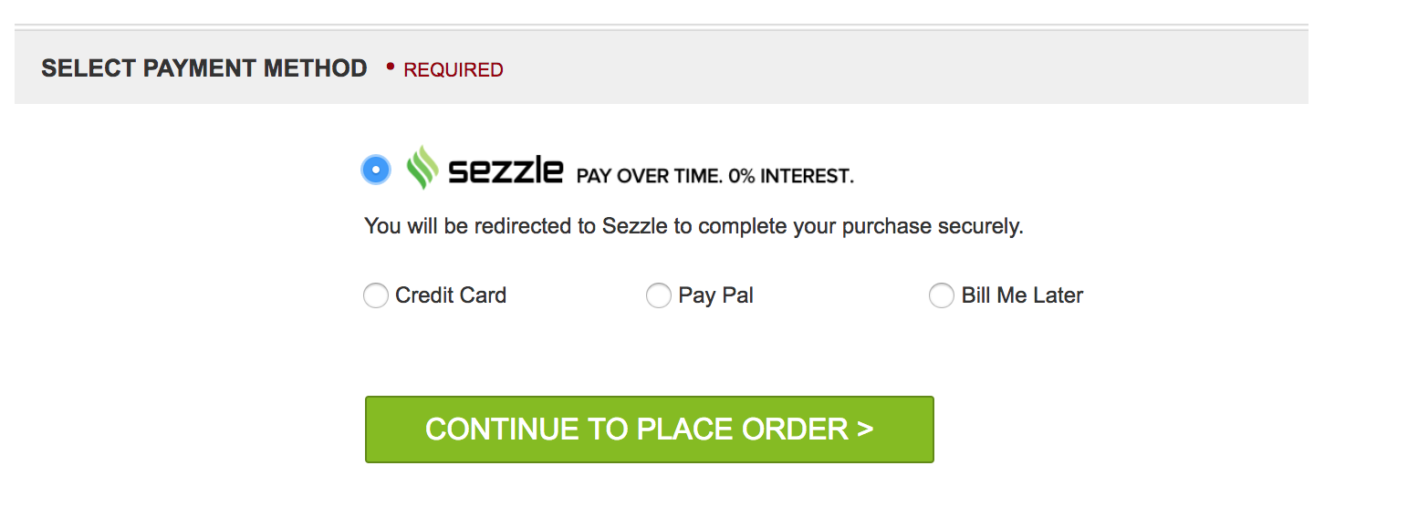

**Step 2**

Proceed to place the order.

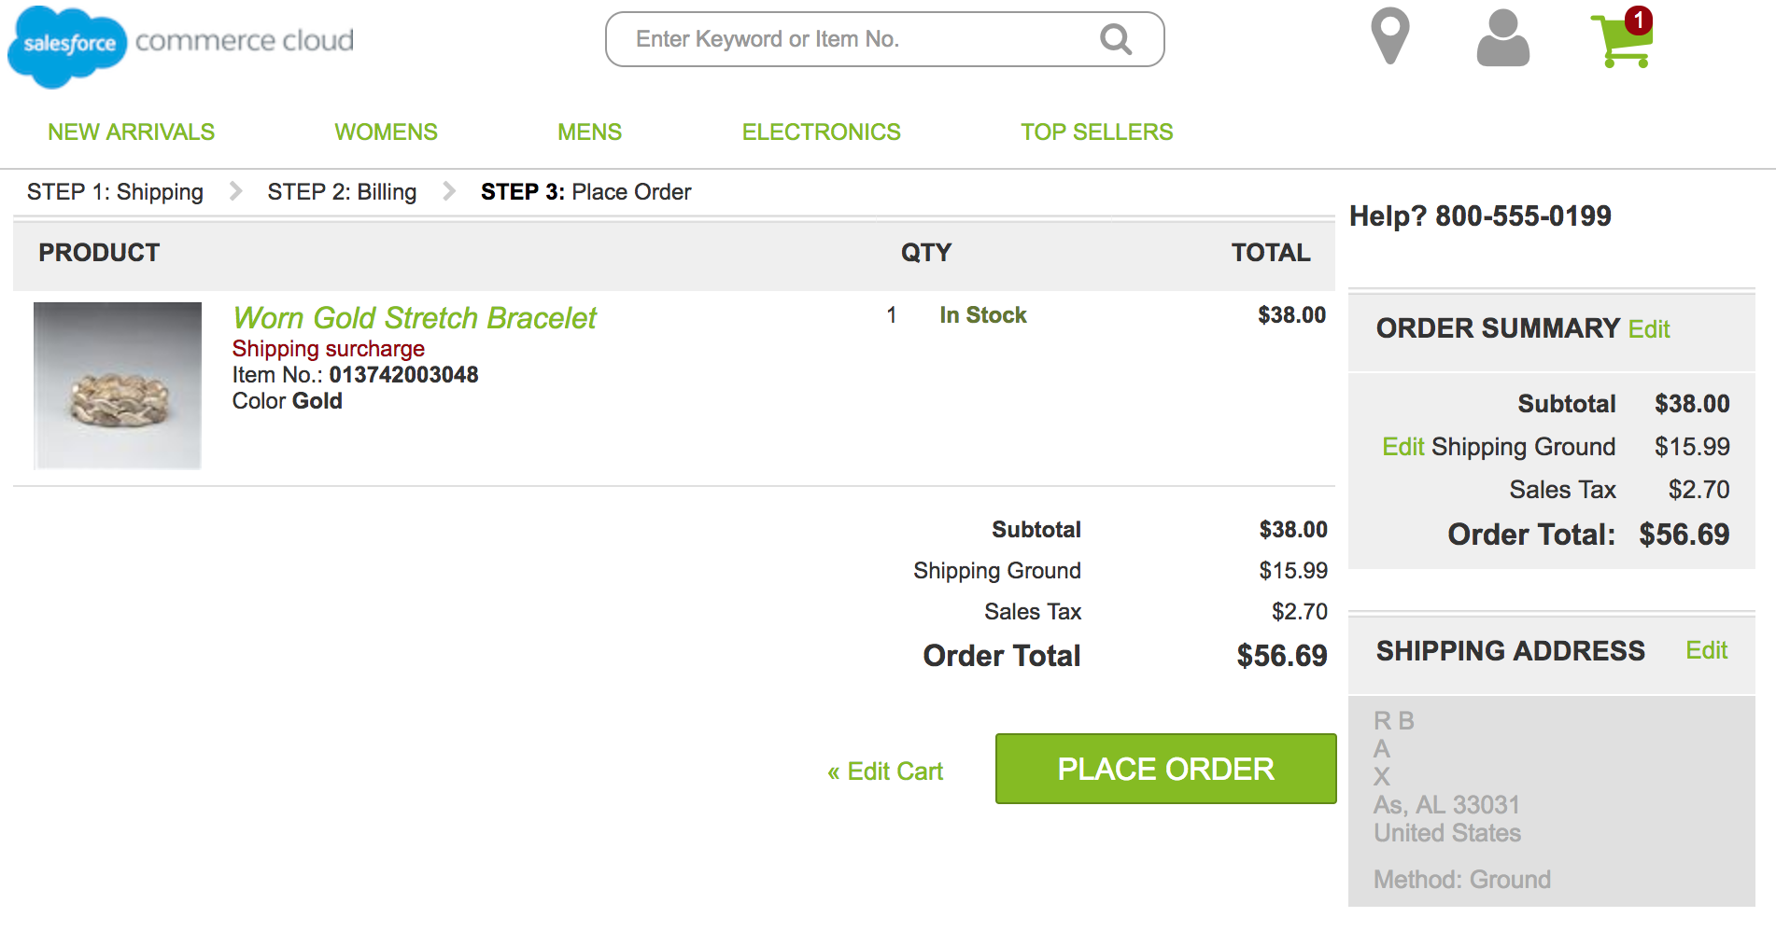

**Step 3**

The page should redirect to Sezzle’s Checkout page, where you will be asked to login/sign up. If you have already signed up, provide your phone number and password and you can proceed to **Step 5.** If you are signing up, check **Step 4**.

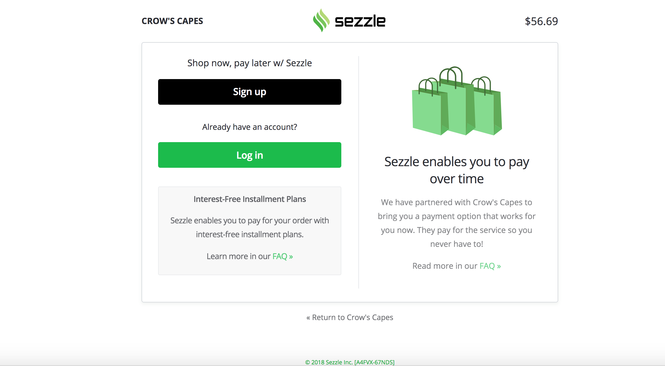

**Step 4**

If you are signing up, fill in the details as asked.

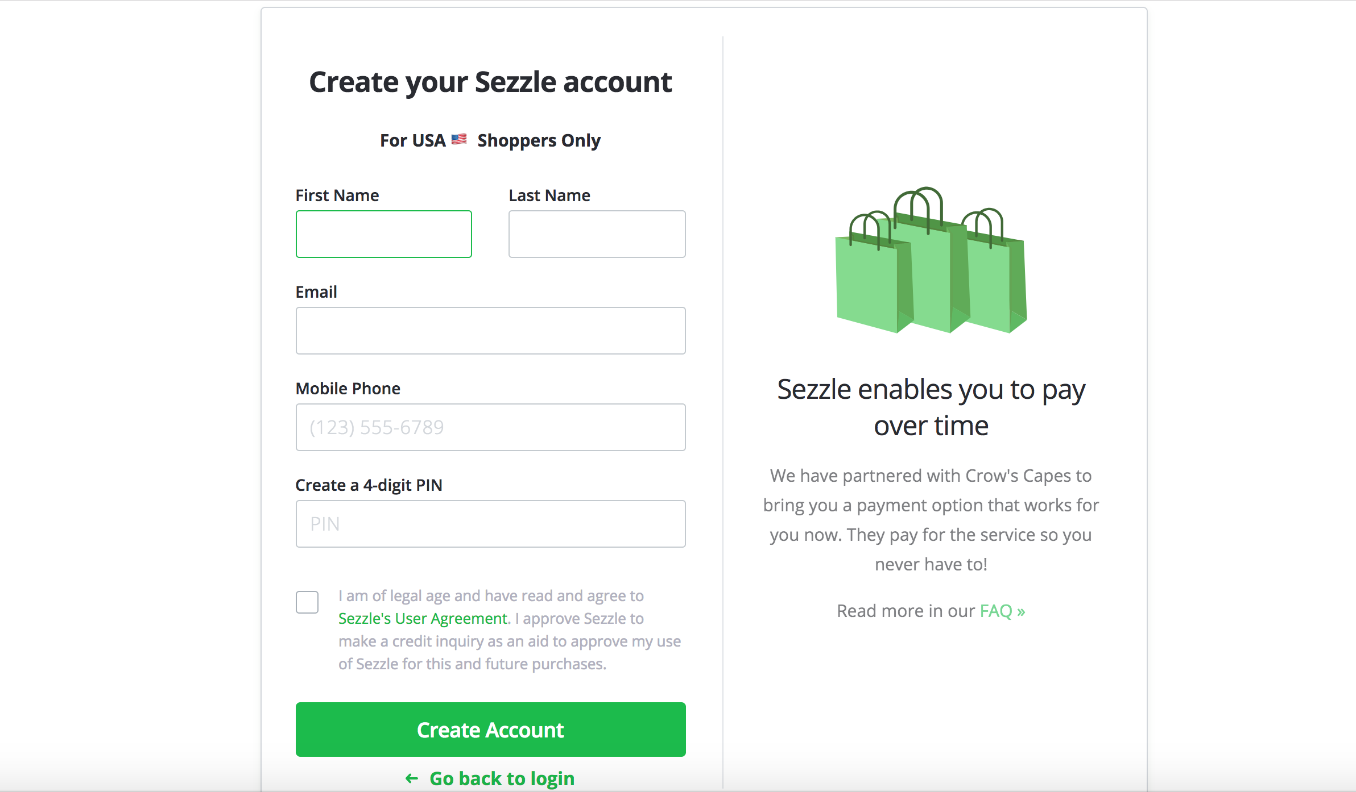

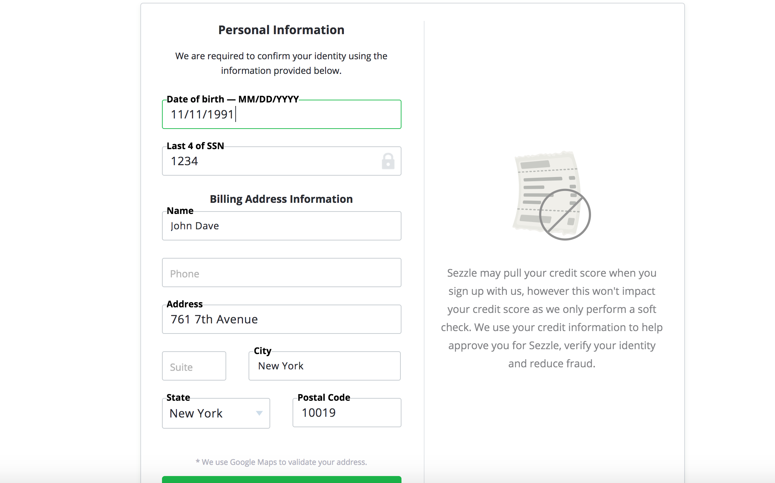

In the step below, you can provide the card number as **‘4111 1111 1111 1111’** and then fill in the rest of the details.

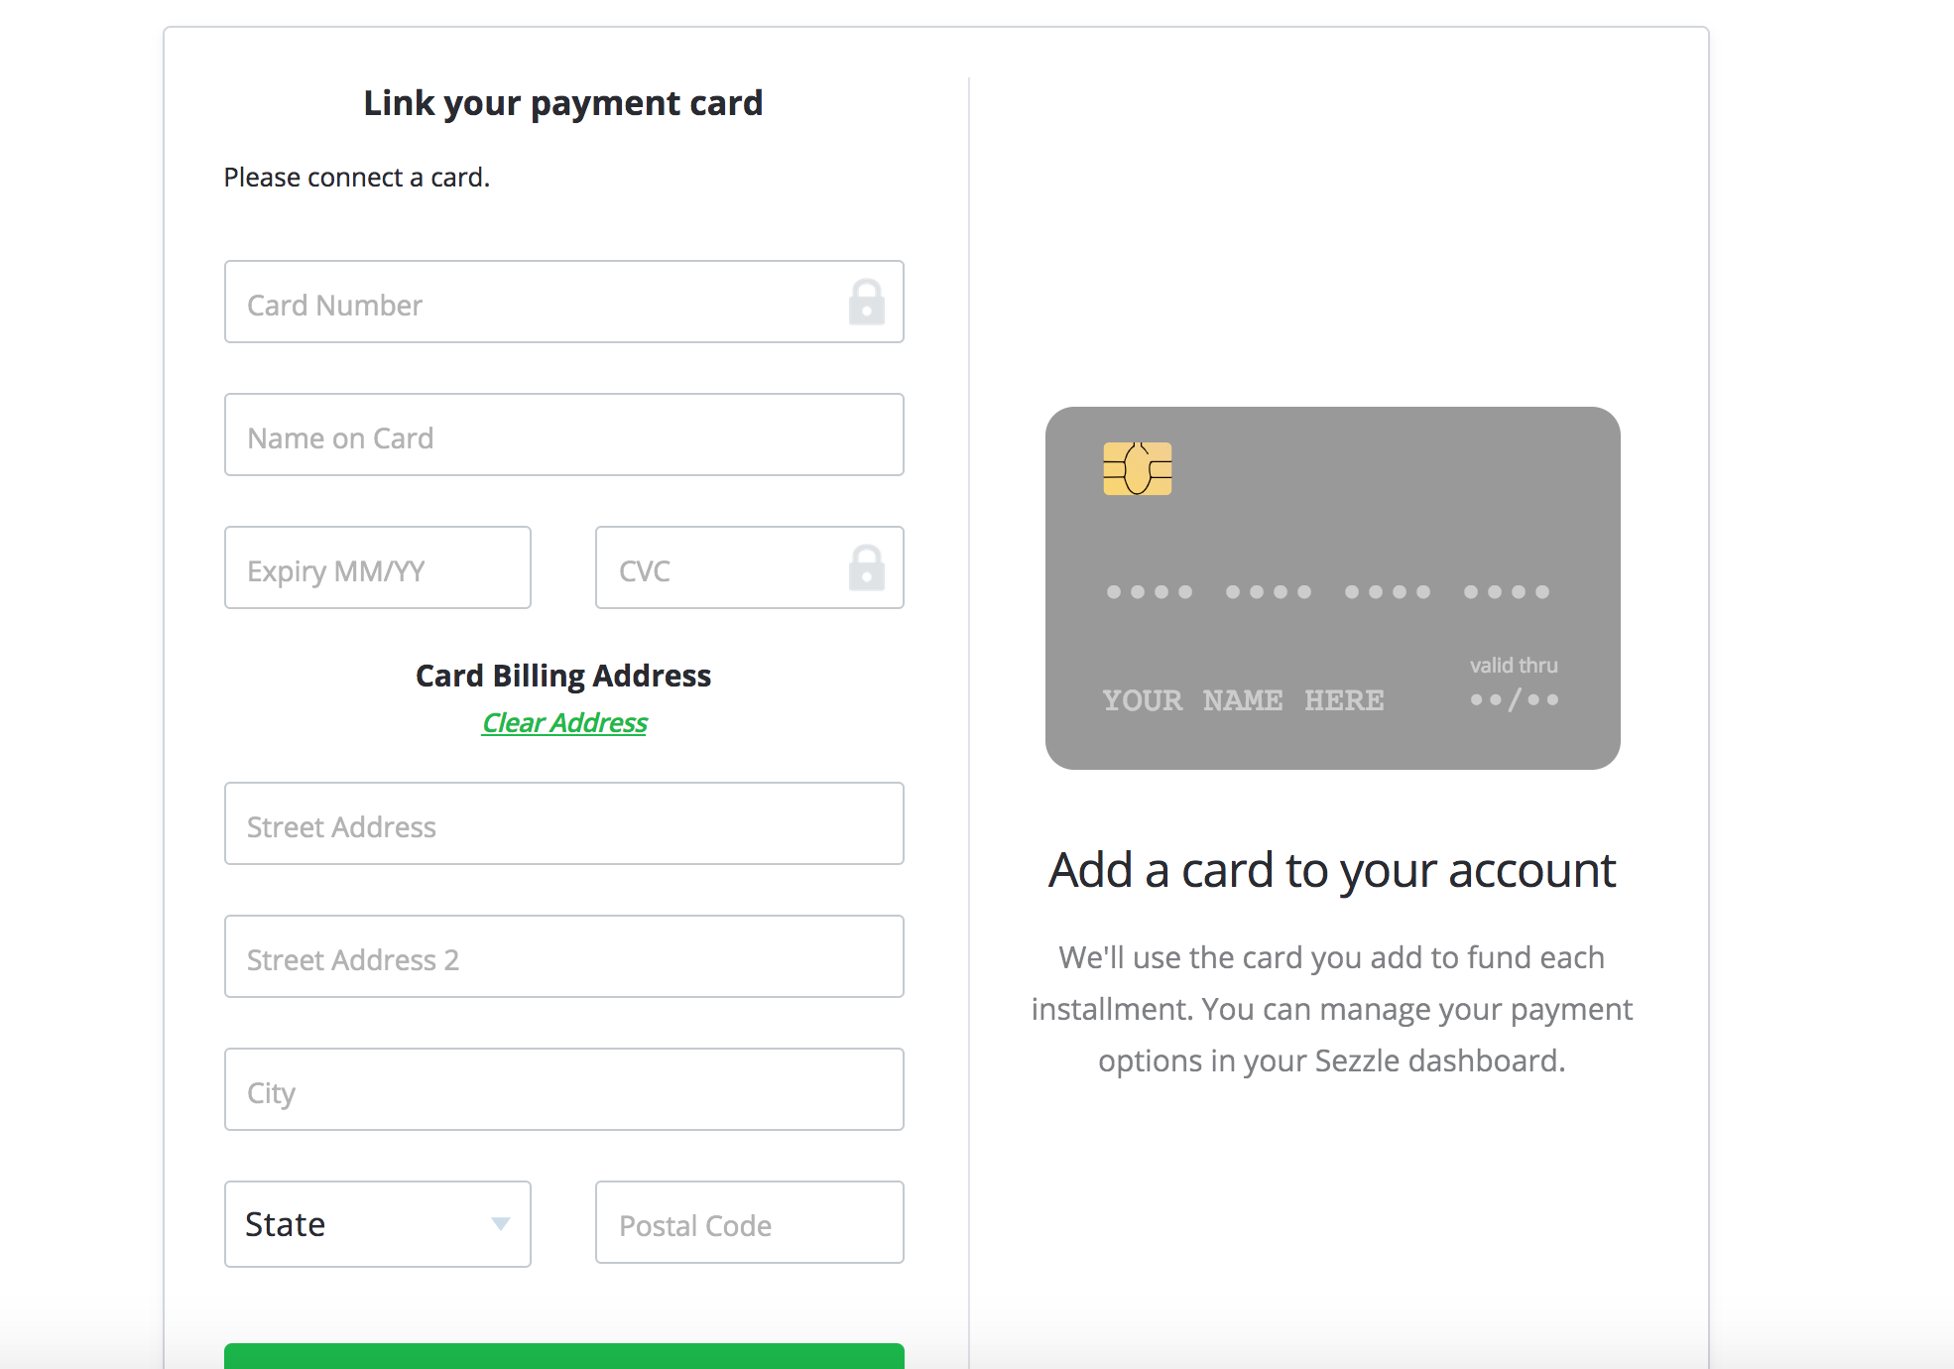

**Step 5**

Click on ‘Complete Order’ below to complete the Checkout.

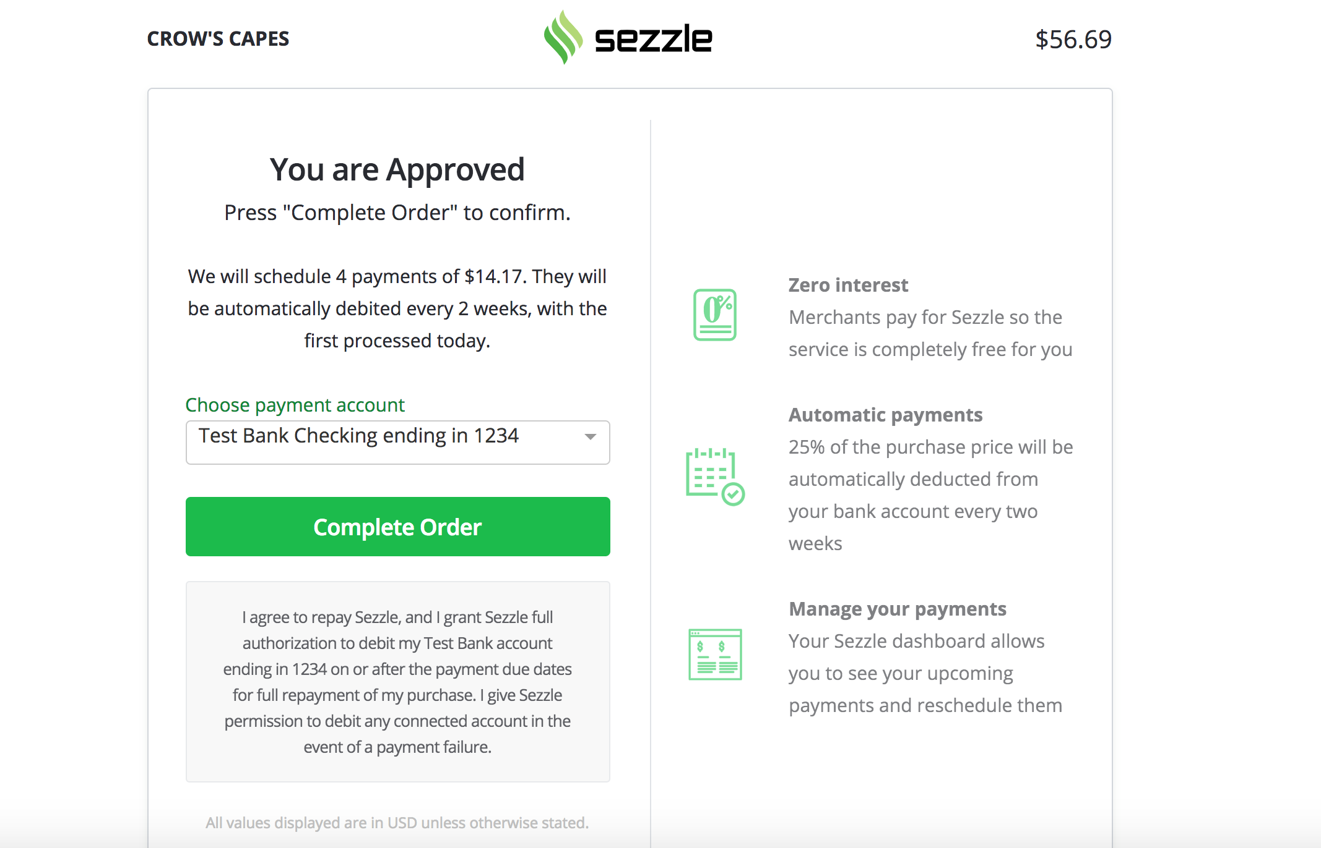

**Order Confirmation**

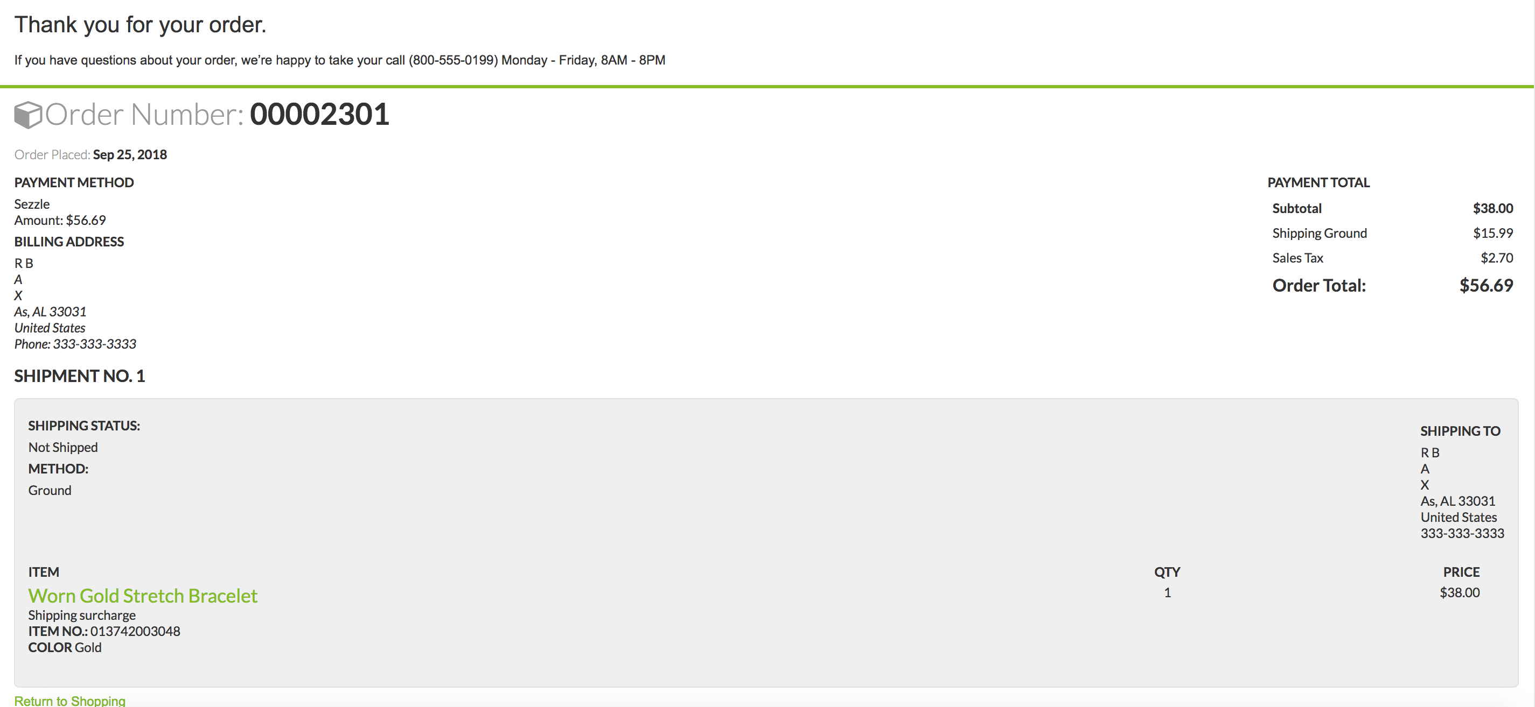Note the order number so that you can check it in the Business Manager in the next section.

# Check the order

Access the order list in the Business Manager: Merchant Tools > Ordering > Orders

A new order should be available, with an order number corresponding to the one you have placed. Click on it to view the order details.

On ‘Attributes’ tab of the order details, you should find information related to the Sezzle payment method.

|  |  |  |  |
| --- | --- | --- | --- |
| |  | | --- | | Sezzle External Id: | | |  | | --- | | <Sezzle External ID> | |
| |  | | --- | | Sezzle Payment Action: | | |  | | --- | | CAPTURE (AUTHORIZATION + CAPTURE) | |
| |  | | --- | | Sezzle Checkout Token: | | |  | | --- | | <Sezzle Checkout Token> | |
| |  | | --- | | Sezzle Status: | |  | | |  | | --- | | CAPTURE (CAPTURED) | |

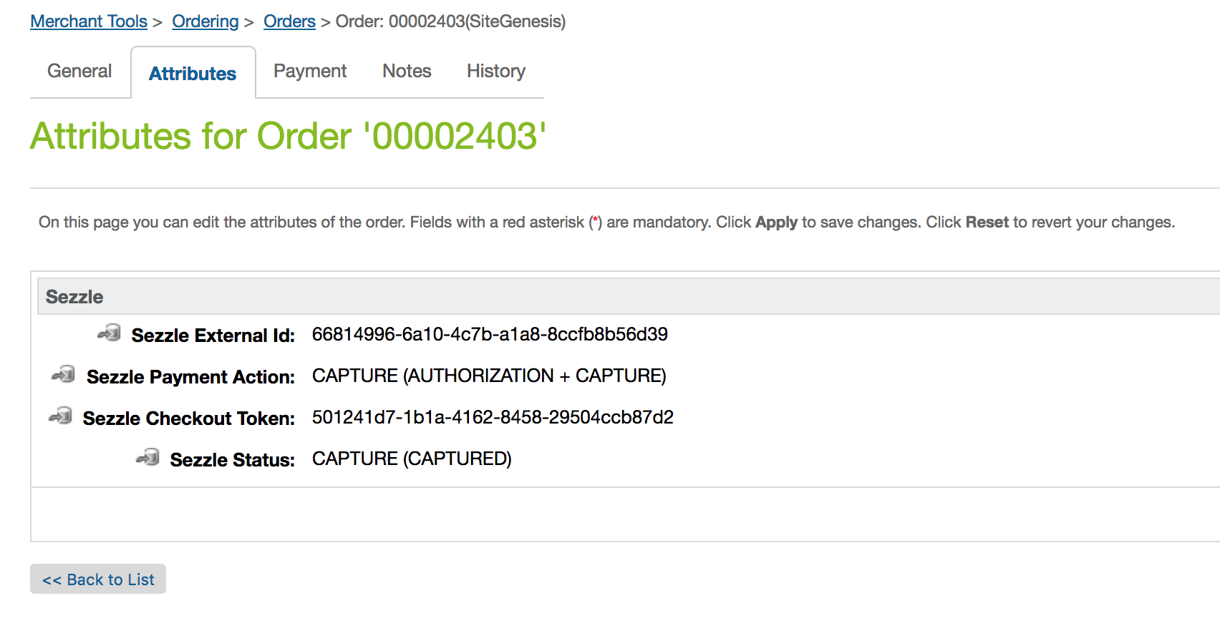

The “Payment Method” in “Payment” tab should contain the following information:

Sezzle   
Processor: SEZZLE_PAYMENT   
Transaction: <Sezzle Order ID>   
Amount: <Amount>

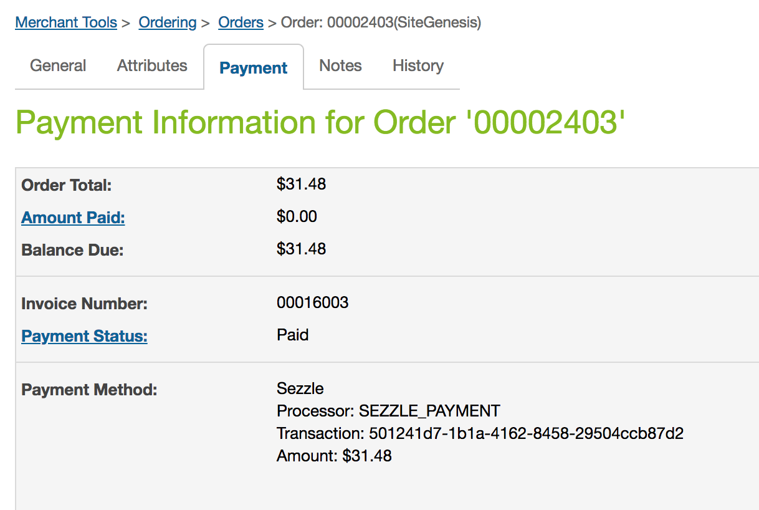

# Refund

In the Business Manager: Merchant Tools > Ordering > Orders. Click on an order to see the order details.

**Cancel an Order**

Click on the ‘Order Status’ inside “General” tab. Select “Cancelled” from the dropdown and then “Apply”. The order status should change to “Cancelled”.

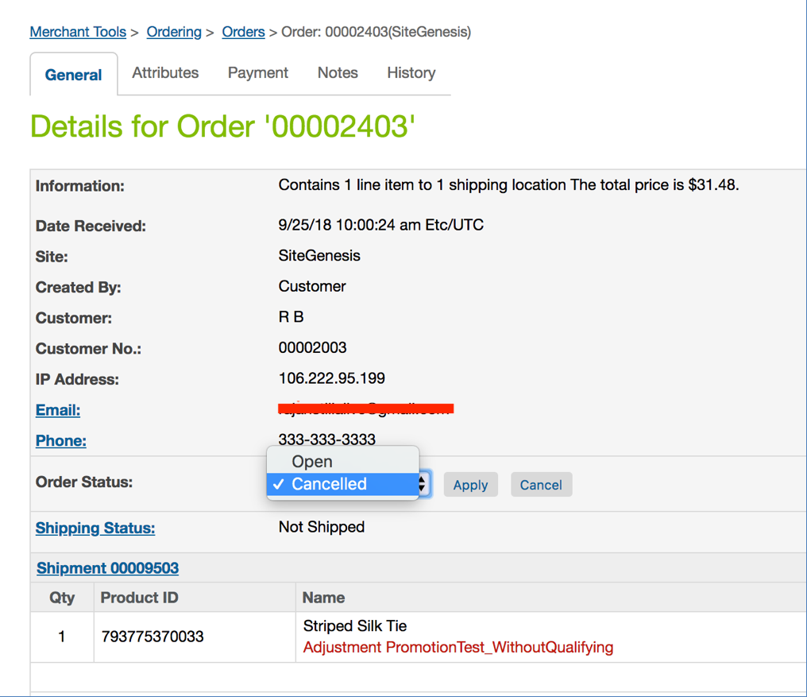

**Process Refund**

Go to Administration->Operations->Job Schedules.

Select the check box beside ‘SezzleRefund’ and click on the ‘Run’ button. If the ‘Auto Refresh’ button is checked, the status should update automatically to “OK” after a few seconds.

